Another technique is called Platt Scalling or Sigmoidal Calibration which says that since we know that most of the calibration curves tends to follow sigmoidal function curve.

Where we have two arguments i.e predicted Yi and actual Yi values which are Yi predicted by model and probability of class label for a given query point respectively.

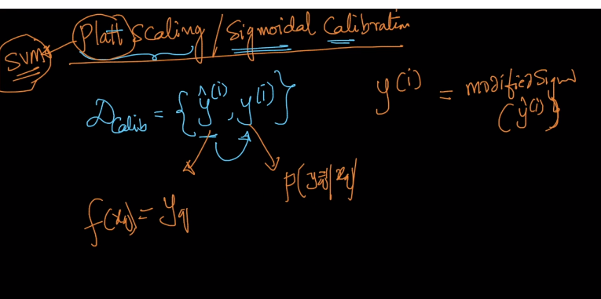

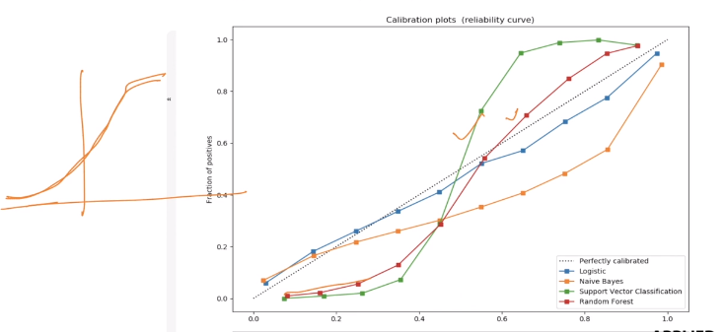

Then Platt says why don’t we put in sigmoidal function as shown below

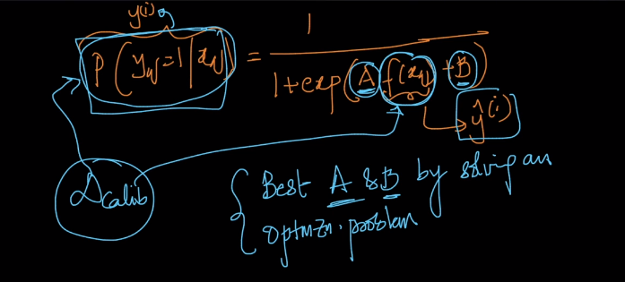

Here using our Calib. Data set we will solve optimization problem to predict best A and B.

But what happens when the calib. Plot does not look like sigmoidal function in shape.

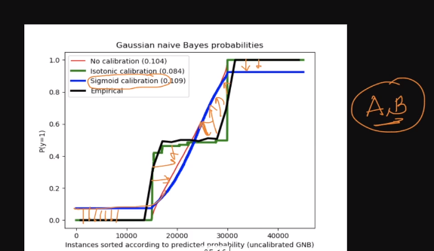

The Black line in above plot is empirical line which are actual D(Calib) points and Dark Blue line is Platts Calib line which is trying to find best values for A and B.

But it is not at all even near to actual points i.e. it is not behaving as it is expected to behave.

SO we can say Sigmoidal Calib. Does not work well when calib. Plot does not behave similar to sigmoidal wave.

What is solution for that?

When we see in graph above the Dark Green line is actually overlapping our data and that is what we expect.

So that plot is generated using Isotonic Calib. Which is most widely used in real world scenerios.

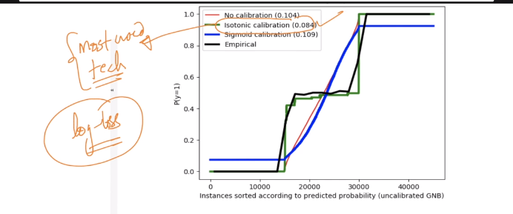

**Comments:**

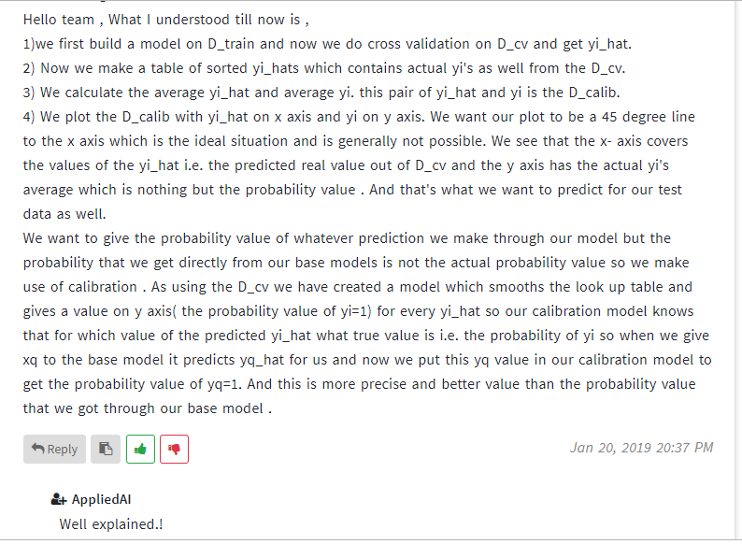



<https://towardsdatascience.com/all-about-naive-bayes-8e13cef044cf>

